Civil war in Georgia

UNSC Resolution: | 1311
Date of adoption: | 07/28/00
Operative paragraph: | 4
Demand number: | 1311.0411

David Siroky

Wording of demand

engage in negotiations on key outstanding issues in the UN-led peace process, including on the distribution of competencies between Tbilisi and Sukhumi as part of a comprehensive settlement

List of addressees of the demand

Government of Georgia, Abkhazia

Short-term compliance

Description of the addressee(s)’ conduct

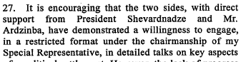

Assessment

s/2000/1023

Short-term compliance
No or marginal compliance (1) | Medium low compliance (2) | Medium high compliance (3)x | Full or almost full compliance (4)

Considerations underlying the assessment

Medium-term compliance

Description of the addressee(s)’ conduct

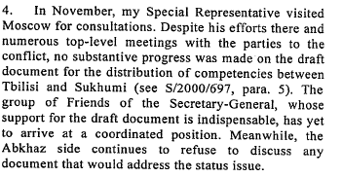

Assessment

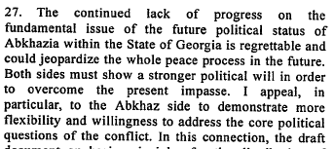

s/2001/59

Medium-term compliance
No or marginal compliance (1) | Medium low compliance (2) | Medium high compliance (3) | Full or almost full compliance (4)

s/2001/59

Considerations underlying the assessment

Depth of demand

Assessment

Level of depth of demand
Low depth of demand (1) | Medium depth of demand (2) | High depth of demand (3)

Considerations underlying the assessment

Level of confidence about coding decisions

Level of confidence about coding decision
Extremely high | High | Moderate

Comments to IPI (if any)

Civil war in Georgia

UNSC Resolution: | 1311
Date of adoption: | 07/28/00
Operative paragraph: | 6
Demand number: | 1311.0611

David Siroky

Wording of demand

implement earlier agreed confidence-building measures and develop further measures on the basis of the relevant document signed in Sukhumi on 11 July 2000

List of addressees of the demand

Government of Georgia, Abkhazia

Short-term compliance

Description of the addressee(s)’ conduct

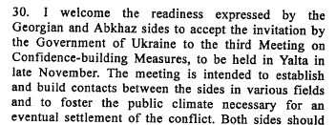

Assessment

S/2000/1023

Short-term compliance
No or marginal compliance (1) | Medium low compliance (2) | Medium high compliance (3) | Full or almost full compliance (4)

Considerations underlying the assessment

Medium-term compliance

Description of the addressee(s)’ conduct

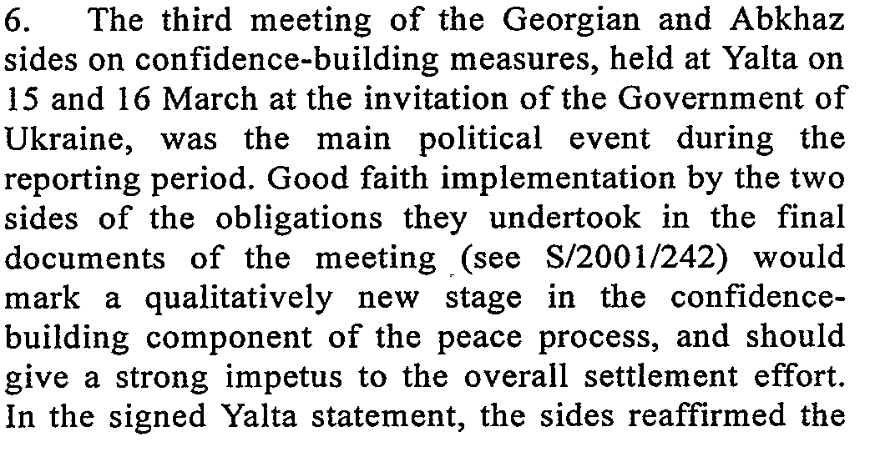

Assessment

s/2001/401
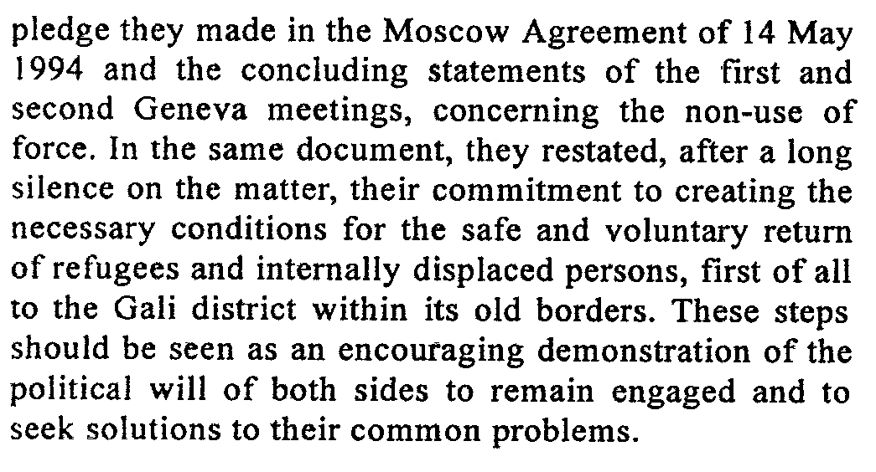

s/2001/401

Medium-term compliance
No or marginal compliance (1) | Medium low compliance (2) | Medium high compliance (3) | Full or almost full compliance (4)

Considerations underlying the assessment

Depth of demand

Assessment

Level of depth of demand
Low depth of demand (1) | Medium depth of demand (2) | High depth of demand (3)

Considerations underlying the assessment

Level of confidence about coding decisions

Level of confidence about coding decision
Extremely high | High | Moderate

Comments to IPI (if any)

Civil war in Georgia

UNSC Resolution: | 1311
Date of adoption: | 07/28/00
Operative paragraph: | 7
Demand number: | 1311.0711

David Siroky

Wording of demand

address urgently the issue of the unacceptability of the demographic changes resulting from the conflict and the imprescriptible right of all refugees and displaced persons affected by the conflict to return to their homes in secure and dignified conditions in accordance with international law and as set out in the Quadripartite Agreement by agreeing and implementing effective measures to guarantee the security of those who exercise their unconditional right of return, including those who have already returned

List of addressees of the demand

Government of Georgia, Abkhazia

Short-term compliance

Description of the addressee(s)’ conduct

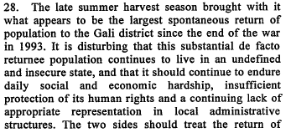

Assessment

s/2000/1023

Short-term compliance
No or marginal compliance (1) | Medium low compliance (2) | Medium high compliance (3) | Full or almost full compliance (4)

Considerations underlying the assessment

Medium-term compliance

Description of the addressee(s)’ conduct

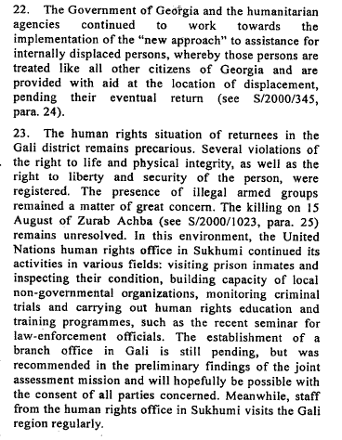

Assessment

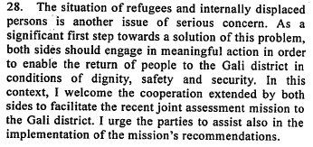

s/2001/59

Medium-term compliance
No or marginal compliance (1) | Medium low compliance (2) | Medium high compliance (3) | Full or almost full compliance (4)

Considerations underlying the assessment

Depth of demand

Assessment

Level of depth of demand
Low depth of demand (1) | Medium depth of demand (2) | High depth of demand (3)

Considerations underlying the assessment

Level of confidence about coding decisions

Level of confidence about coding decision
Extremely high | High | Moderate

Comments to IPI (if any)

Civil war in Georgia

UNSC Resolution: | 1311
Date of adoption: | 07/28/00
Operative paragraph: | 8
Demand number: | 1311.0811

David Siroky

Wording of demand

in the context of op. 7 of current resolution, address urgently and in a concerted manner, as a first step, the undefined and insecure status of spontaneous returnees to the Gali district, including the re-establishment of functioning local administrative structures in which the returnee population is appropriately represented

List of addressees of the demand

Government of Georgia, Abkhazia

Short-term compliance

Description of the addressee(s)’ conduct

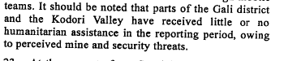

Assessment

S/2000/1023

s/2000/1023

Short-term compliance
No or marginal compliance (1) | Medium low compliance (2) | Medium high compliance (3) | Full or almost full compliance (4)

Considerations underlying the assessment

Medium-term compliance

Description of the addressee(s)’ conduct

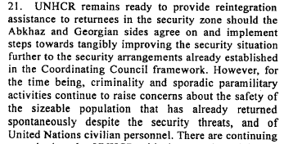

Assessment

s/2001/59

s/2001/59

Medium-term compliance
No or marginal compliance (1) | Medium low compliance (2) | Medium high compliance (3) | Full or almost full compliance (4)

Considerations underlying the assessment

Depth of demand

Assessment

Level of depth of demand
Low depth of demand (1) | Medium depth of demand (2) | High depth of demand (3)

Considerations underlying the assessment

Level of confidence about coding decisions

Level of confidence about coding decision
Extremely high | High | Moderate

Comments to IPI (if any)

Civil war in Georgia

UNSC Resolution: | 1311
Date of adoption: | 07/28/00
Operative paragraph: | 10
Demand number: | 1311.1011

David Siroky

Wording of demand

take urgent measures to cooperate with opposing side in the fight against crime of all sorts and in improving the work of their respective law enforcement organs

List of addressees of the demand

Government of Georgia, Abkhazia

Short-term compliance

Description of the addressee(s)’ conduct

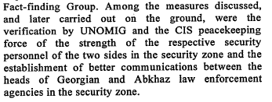

Assessment

s/2000/1023

Short-term compliance
No or marginal compliance (1) | Medium low compliance (2) | Medium high compliance (3) | Full or almost full compliance (4)

Considerations underlying the assessment

Medium-term compliance

Description of the addressee(s)’ conduct

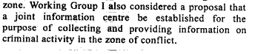

s/2001/59

Assessment

Medium-term compliance
No or marginal compliance (1) | Medium low compliance (2) | Medium high compliance (3) | Full or almost full compliance (4)

Considerations underlying the assessment

Depth of demand

Assessment

Level of depth of demand
Low depth of demand (1) | Medium depth of demand (2) | High depth of demand (3)

Considerations underlying the assessment

Level of confidence about coding decisions

Level of confidence about coding decision
Extremely high | High | Moderate

Comments to IPI (if any)

Civil war in Georgia

UNSC Resolution: | 1311
Date of adoption: | 07/28/00
Operative paragraph: | 11
Demand number: | 1311.1111

David Siroky

Wording of demand

observe strictly the Moscow Agreement [S/1994/583 annex 1]

List of addressees of the demand

Government of Georgia, Abkhazia

Short-term compliance

Description of the addressee(s)’ conduct

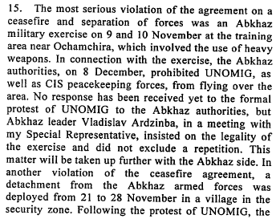

Assessment

s/2001/59

Short-term compliance
No or marginal compliance (1) | Medium low compliance (2) | Medium high compliance (3) | Full or almost full compliance (4)

Considerations underlying the assessment

Medium-term compliance

Description of the addressee(s)’ conduct

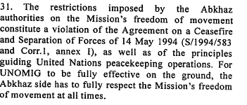

Assessment

s/2001/59

Medium-term compliance
No or marginal compliance (1) | Medium low compliance (2) | Medium high compliance (3) | Full or almost full compliance (4)

Considerations underlying the assessment

Depth of demand

Assessment

Level of depth of demand
Low depth of demand (1) | Medium depth of demand (2) | High depth of demand (3)

Considerations underlying the assessment

Level of confidence about coding decisions

Level of confidence about coding decision
Extremely high | High | Moderate

Comments to IPI (if any)

